
Monday Activity Schedule
- Check It Off When Completed | Activity
 | Morning Work
 | Reading Comprehension Worksheet
 | Independent reading 20 minutes
 | Book Story Map
 | 25 minutes of Lexia or RazKids
 | Math Worksheet
 | 30 minutes of SplashMath or Zearn
 | Skills Worksheet
 | *Choice activity time: pick an activity from the ClassDojo class story (watch a read aloud, try a learning website, or reading journal entry) or independent read for 20 minutes
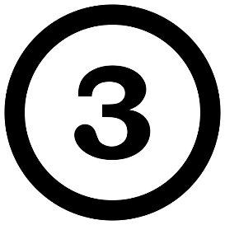
Morning Work- Monday
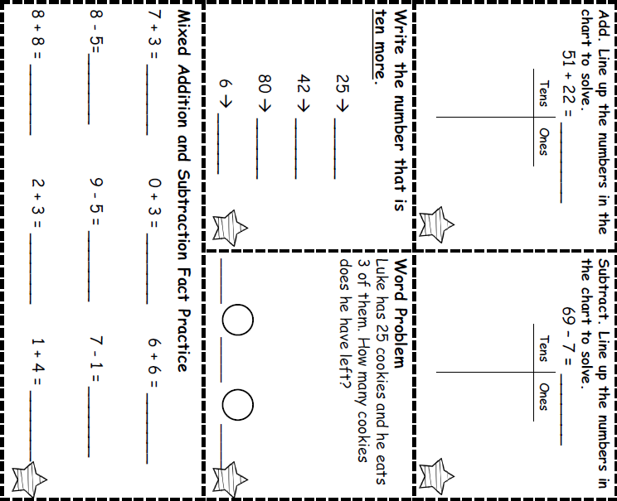

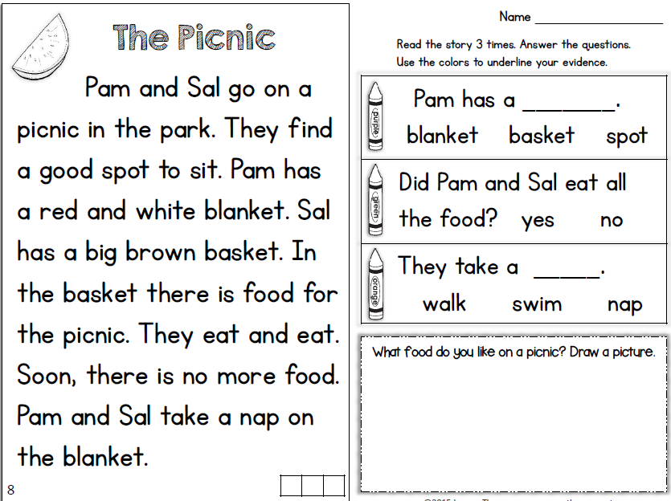

Monday- Reading
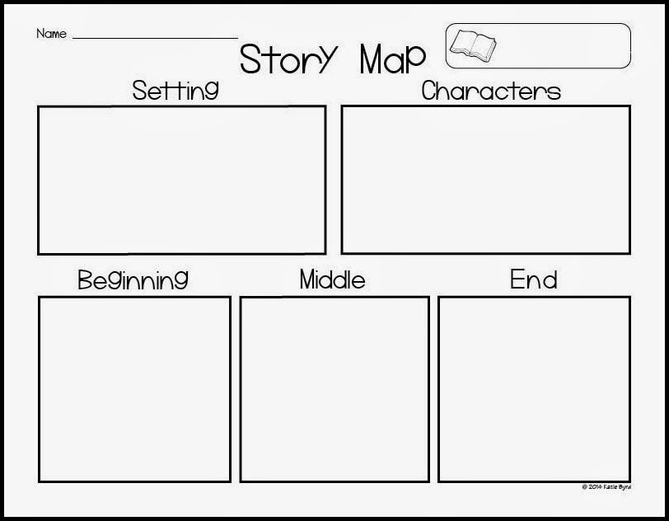
* Read a book and complete this story map.****
Monday- Reading
Monday- Math
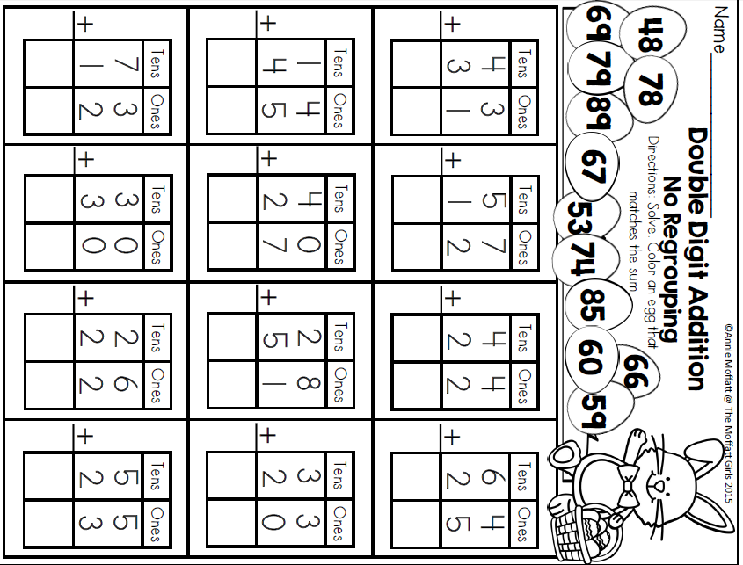
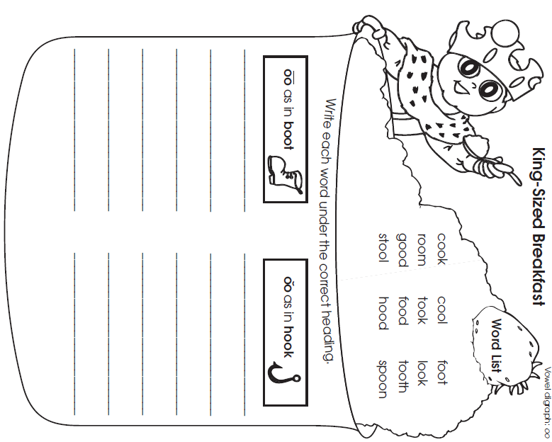
Monday- Skills
Tuesday Activity Schedule
- Check It Off When Completed | Activity
 | Morning Work
 | Writing a story Worksheet
 | Reading Comprehension
 | Independent reading 20 minutes & Book Story Map
 | 25 minutes of Lexia or RazKids
 | Math Worksheet
 | 30 minutes of SplashMath or Zearn
 | Skills Worksheet
 | *Choice activity time: pick an activity from the ClassDojo class story (watch a read aloud, try a learning website, or reading journal entry) or independent read for 20 minutes
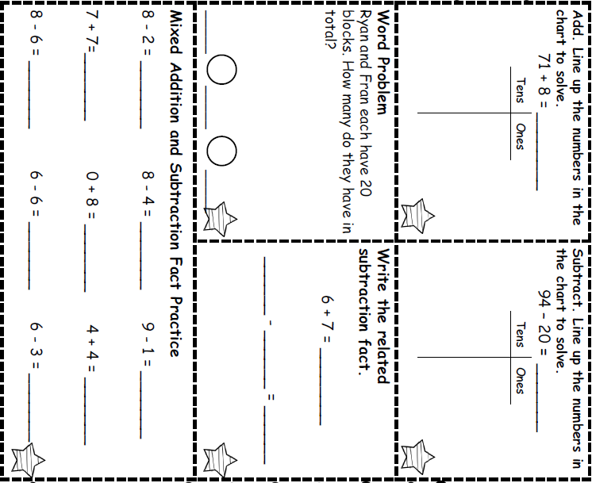
Morning Work- Tuesday

_

Words to use:
- polar bear
- train
- ride
- people

_____________________________________________________________________________________________________________________________________________________________________________________________________________________________________________________________________________________________________________________________________________________________________________________________________________________________________________________________________________________________________________
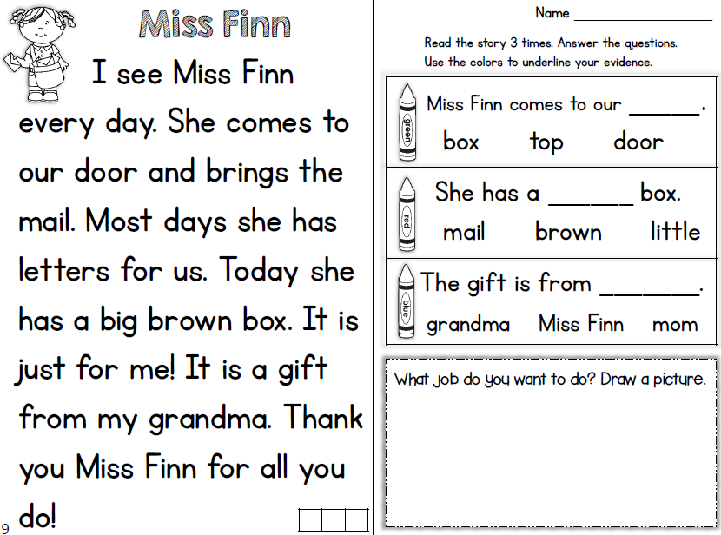

Tuesday- Reading
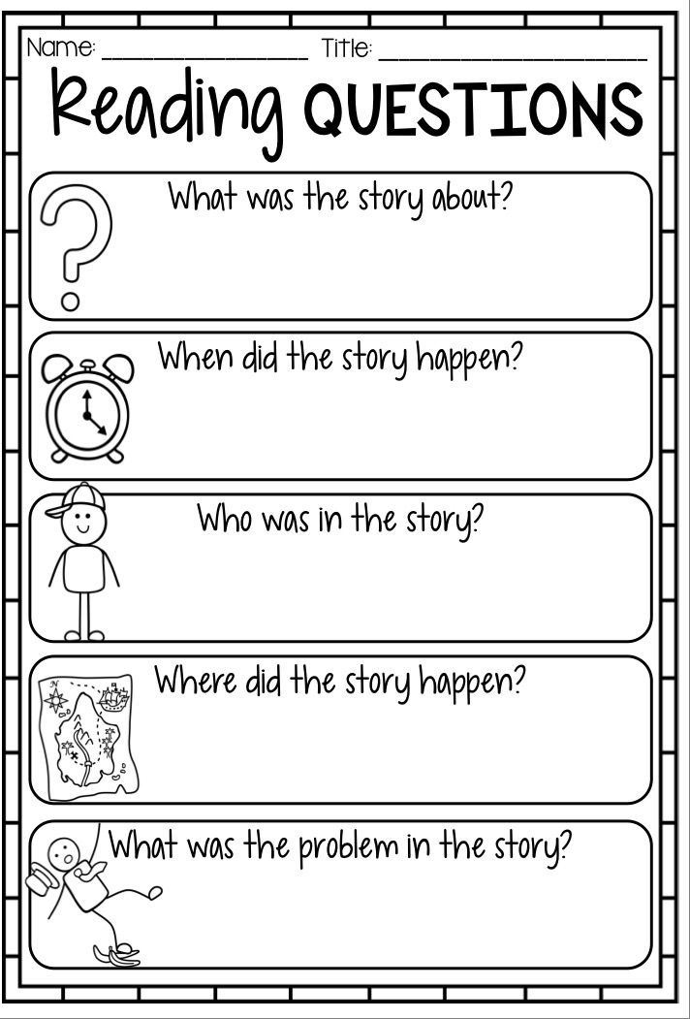
Read a book and complete this story map
Tuesday- Reading

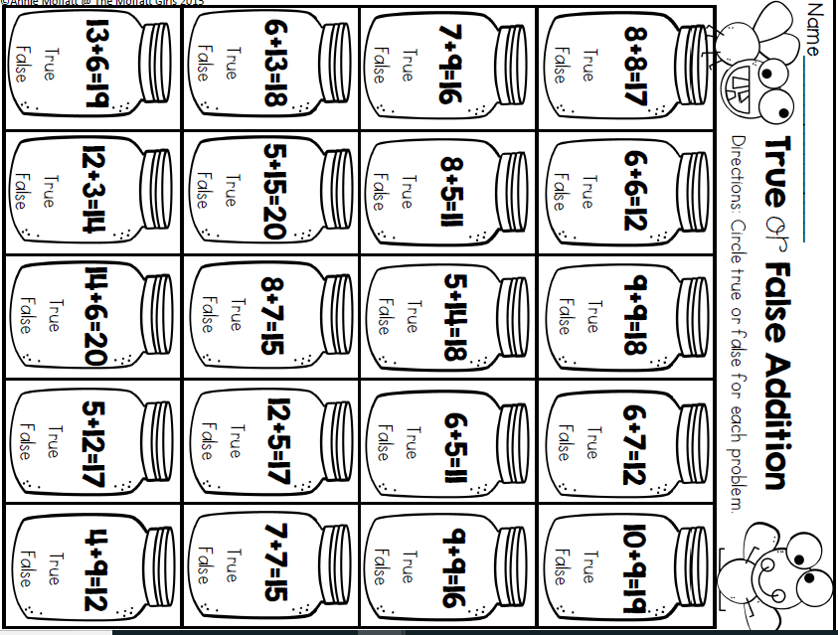
Tuesday- Math
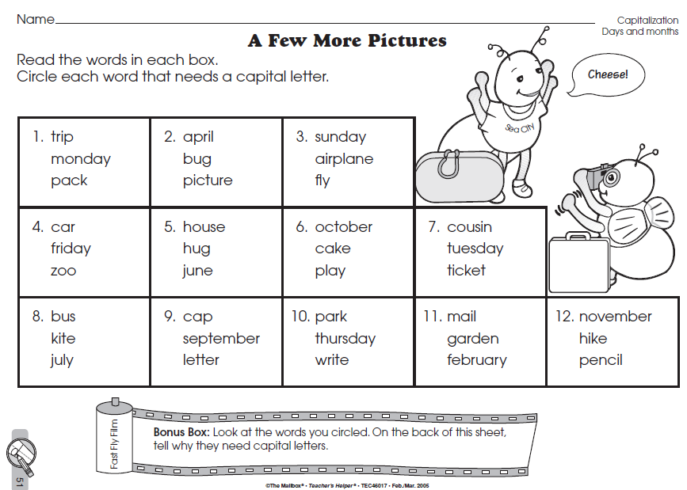
Tuesday- Skills


Wednesday Activity Schedule
- Check It Off When Completed | Activity
 | Morning Work
 | Writing a story
 | Independent Reading 20 minutes
 | Reading Comprehension Worksheet
 | 40 minutes of Lexia or RazKids
 | Math Worksheet
 | 40 minutes of SplashMath or Zearn
 | Skills Worksheet
 | *Choice activity time: pick an activity from the ClassDojo class story (watch a read aloud, try a learning website, or reading journal entry) or independent read for 20 minutes
Morning Work- Wednesday
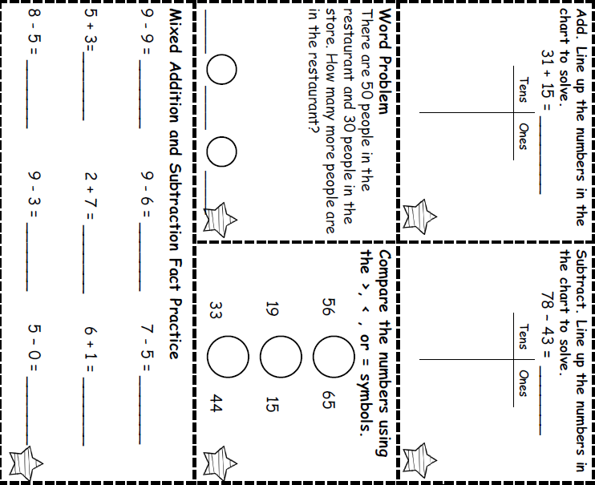

_

Words to use:
- cowboy
- cat
- horse
- giant

_____________________________________________________________________________________________________________________________________________________________________________________________________________________________________________________________________________________________________________________________________________________________________________________________________________________________________________________________________________________________________________

Wednesday - Reading
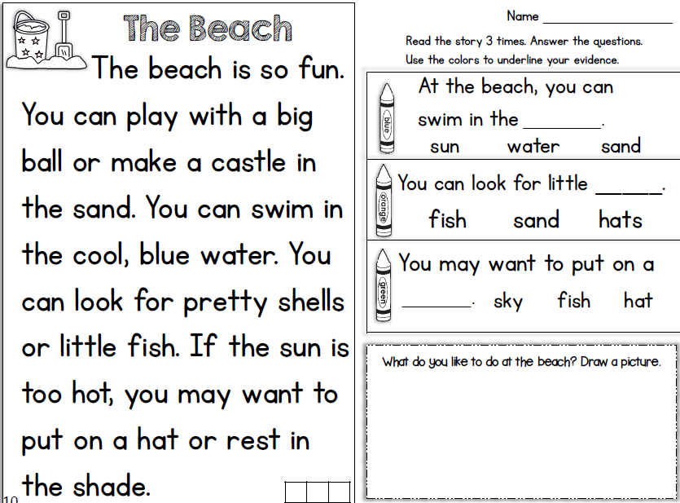
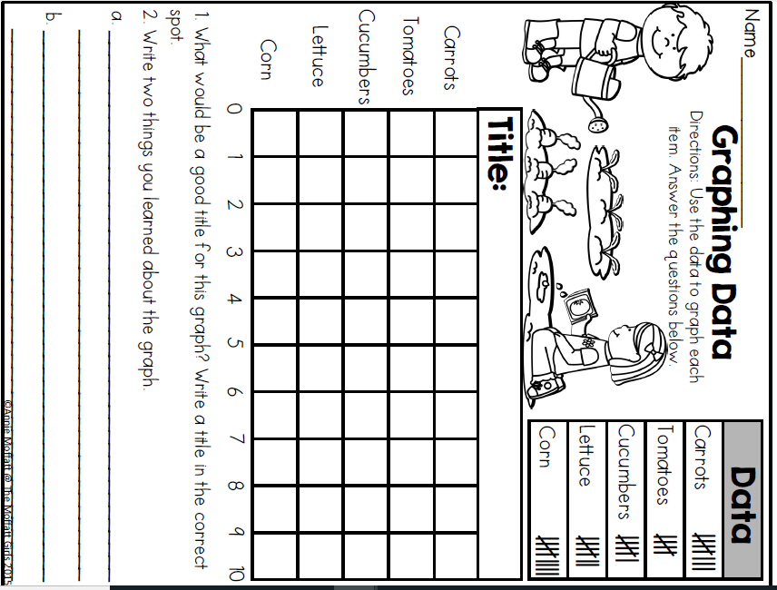
Wednesday- Math

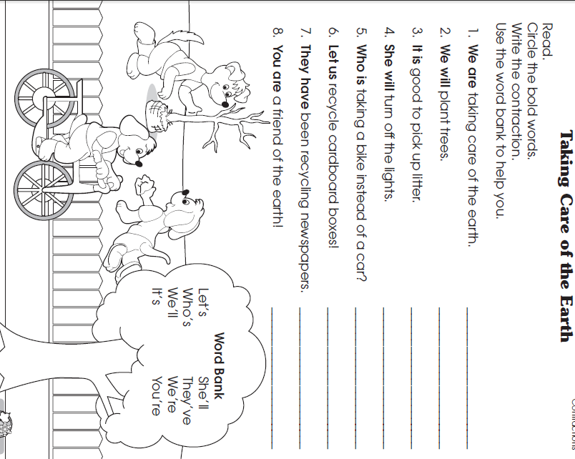
Wednesday- Skills


Thursday Activity Schedule
- Check It Off When Completed | Activity
 | Morning Work
 | Reading Comprehension Worksheet
 | Independent Reading 20 Minutes
 | Book story map
 | 30 minutes of Lexia or RazKids
 | Math Worksheet
 | 30 minutes of SplashMath or Zearn
 | Skills Worksheet
 | *Choice activity time: pick an activity from the ClassDojo class story (watch a read aloud, try a learning website, or reading journal entry) or independent read for 20 minutes

Morning Work- Thursday
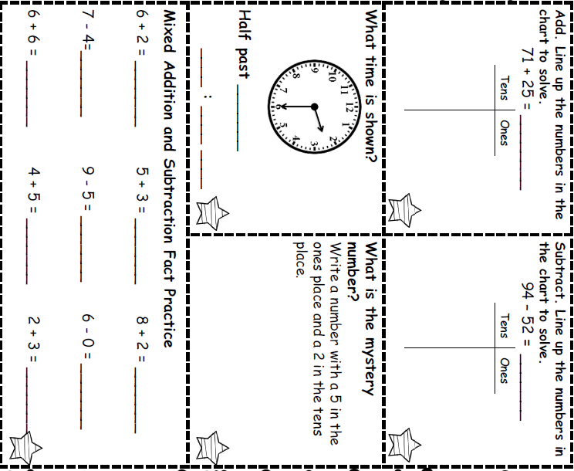

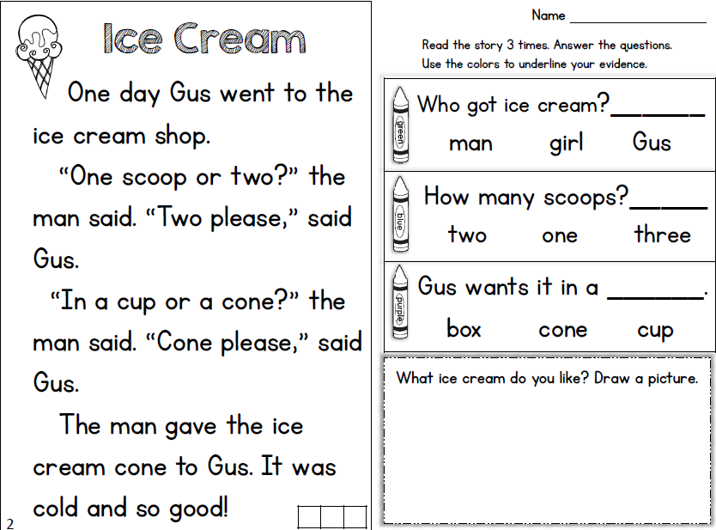

Thursday- Reading
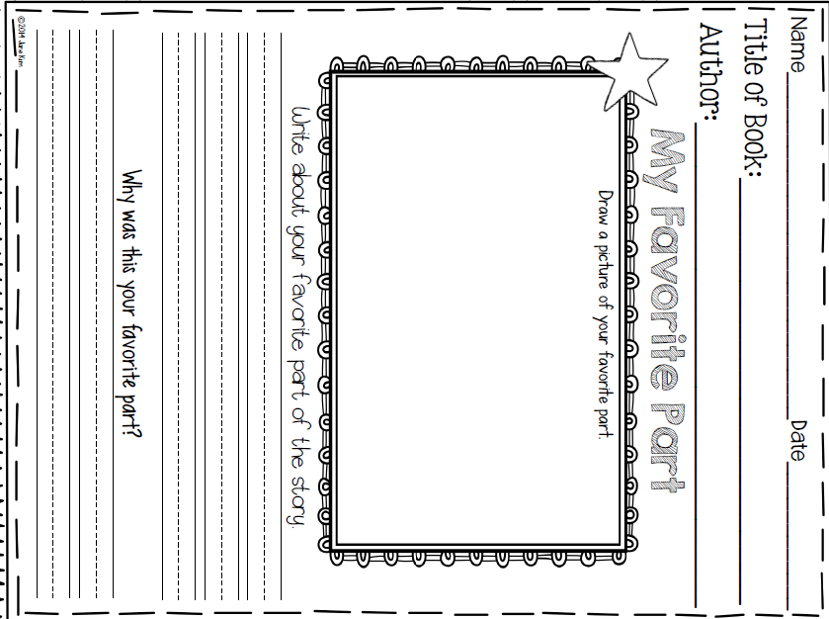

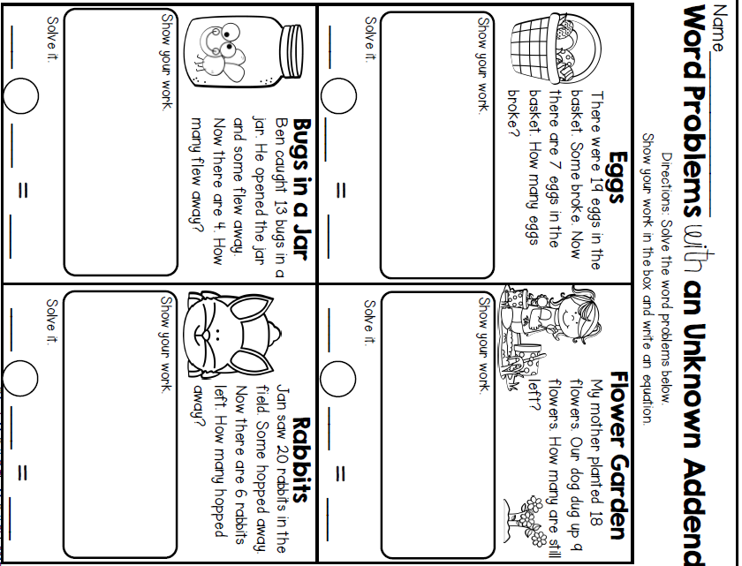
Thursday- Math

Thursday Skills
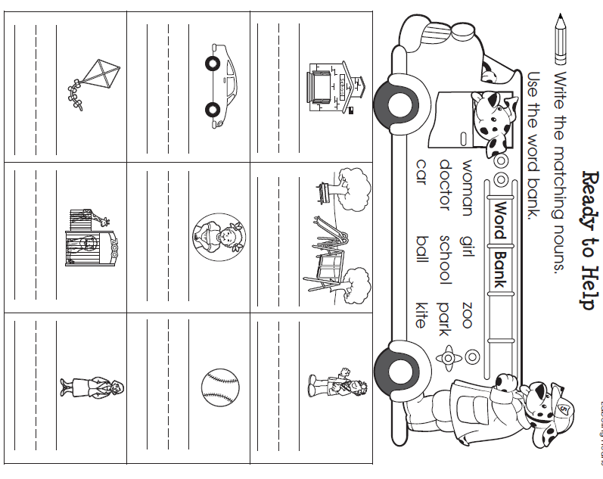


Friday Activity Schedule
- Check It Off When Completed | Activity
 | Morning Work
 | Writing a story
 | Independent reading 20 minutes
 | Reading Comprehension page
 | 40 minutes of Lexia or RazKids
 | Math Worksheet
 | 40 minutes of SplashMath or Zearn
 | Skills Worksheet
 | *Choice activity time: pick an activity from the ClassDojo class story (watch a read aloud, try a learning website, or reading journal entry) or independent read for 20 minutes

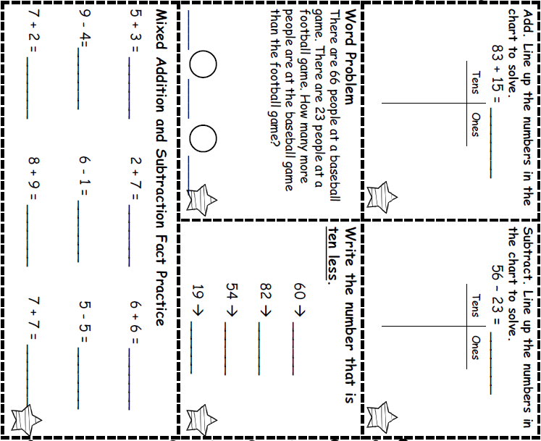
___________________________
Morning Work- Friday

_______________________________________________________________________________________________________________________________________________________________________________________________________________________________________________________________________________________________________________________________________________________________________________________________________________________________________________________________________________________________________________________________________________________________________________

Words to use:
- chef
- cooking
- apron
- dinner

_____________________________________________________________________________________________________________________________________________________________________________________________________________________________________________________________________________________________________________________________________________________________________________________________________________________________________________________________________________________________________________
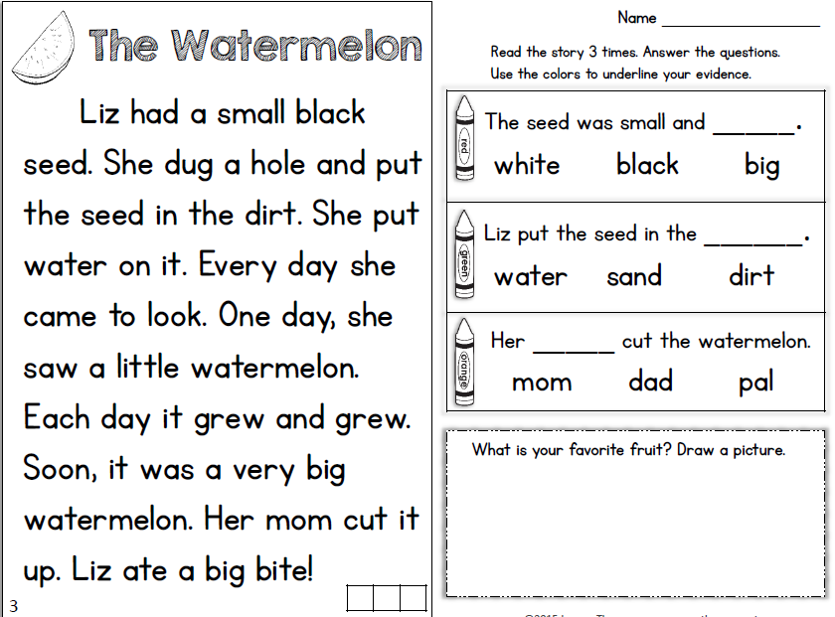

Friday Reading

Friday Math

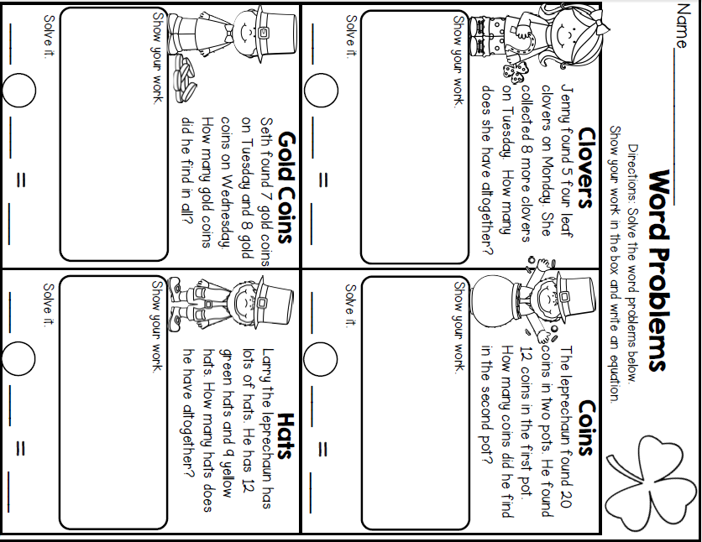

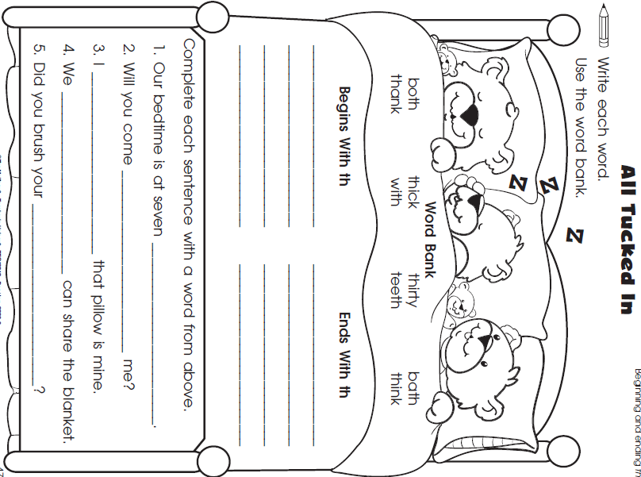
Friday Skills

Monday Activity Schedule
- Check It Off When Completed | Activity
 | Morning Work
 | Reading Comprehension Worksheet
 | Independent reading 20 minutes
 | Book Story Map
 | 25 minutes of Lexia or RazKids
 | Math Worksheet
 | 30 minutes of SplashMath or Zearn
 | Skills Worksheet
 | *Choice activity time: pick an activity from the ClassDojo class story (watch a read aloud, try a learning website, or reading journal entry) or independent read for 20 minutes
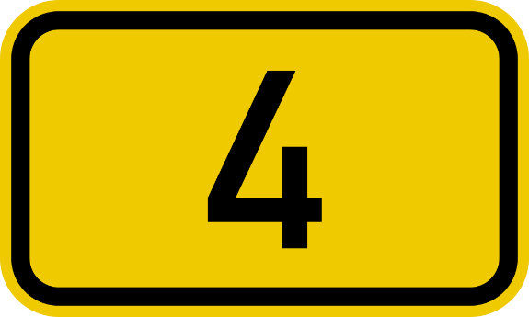
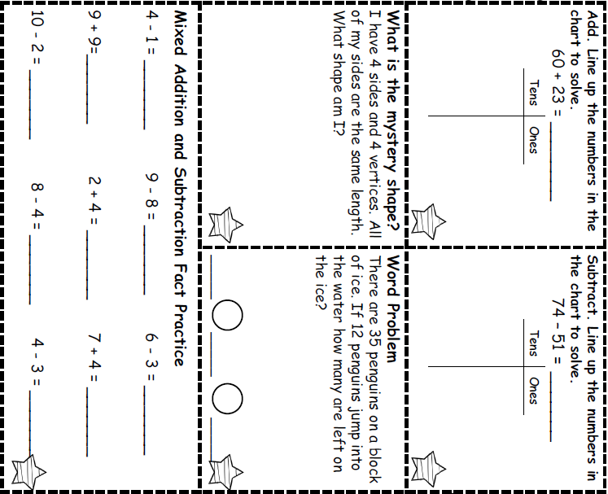
Morning Work- Monday

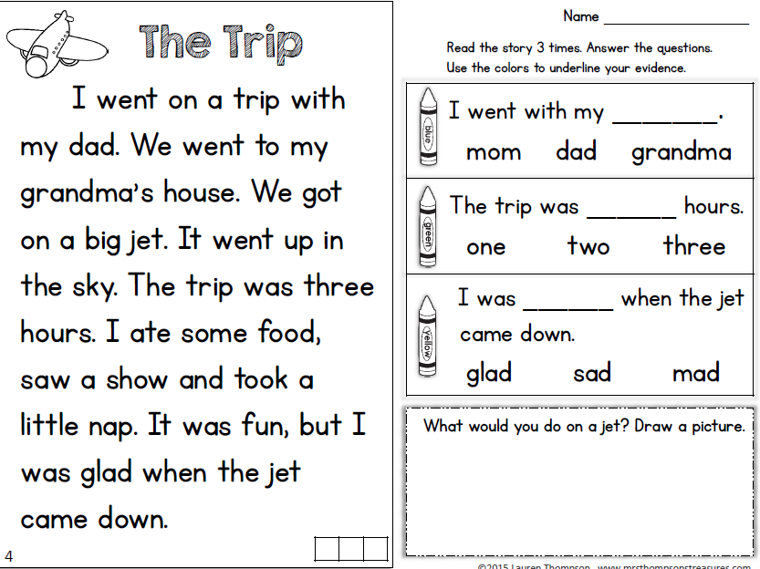
Monday- Reading
* Read a book and complete this story map.****
Monday- Reading
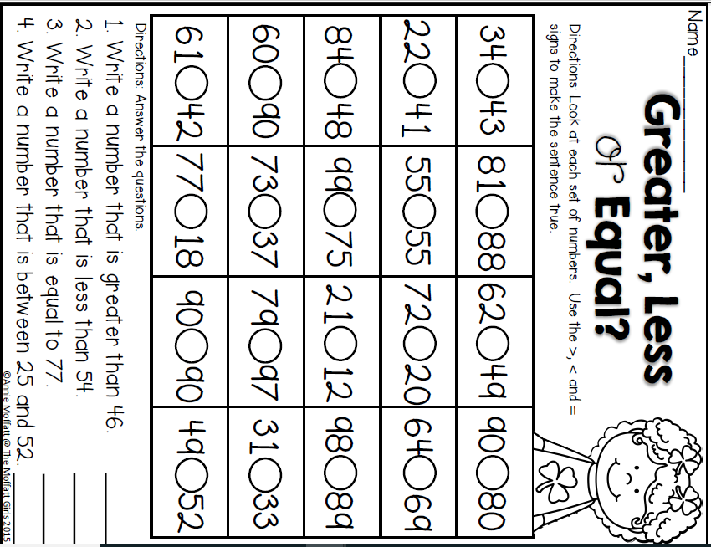
Monday- Math

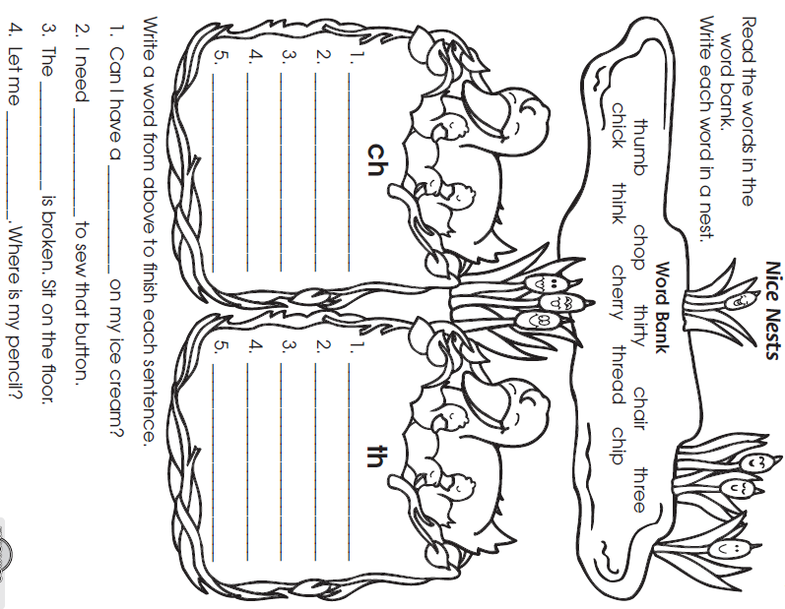
Monday- Skills
Tuesday Activity Schedule
- Check It Off When Completed | Activity
 | Morning Work
 | Reading Comprehension Worksheet
 | Independent reading 20 minutes
 | Book Story Map
 | 25 minutes of Lexia or RazKids
 | Math Worksheet
 | 30 minutes of SplashMath or Zearn
 | Skills Worksheet
 | *Choice activity time: pick an activity from the ClassDojo class story (watch a read aloud, try a learning website, or reading journal entry) or independent read for 20 minutes

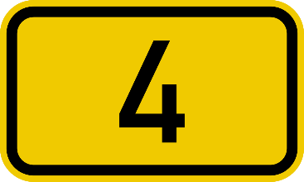
Morning Work- Tuesday
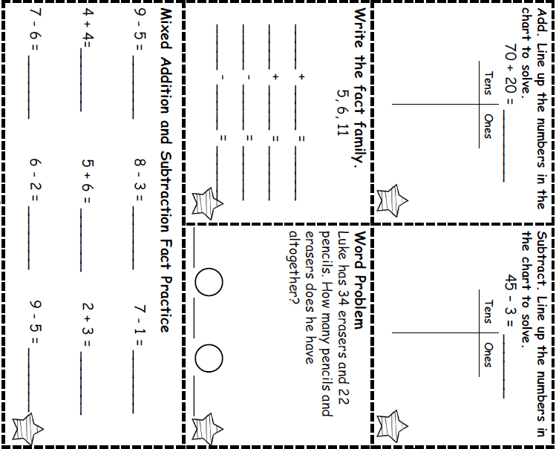

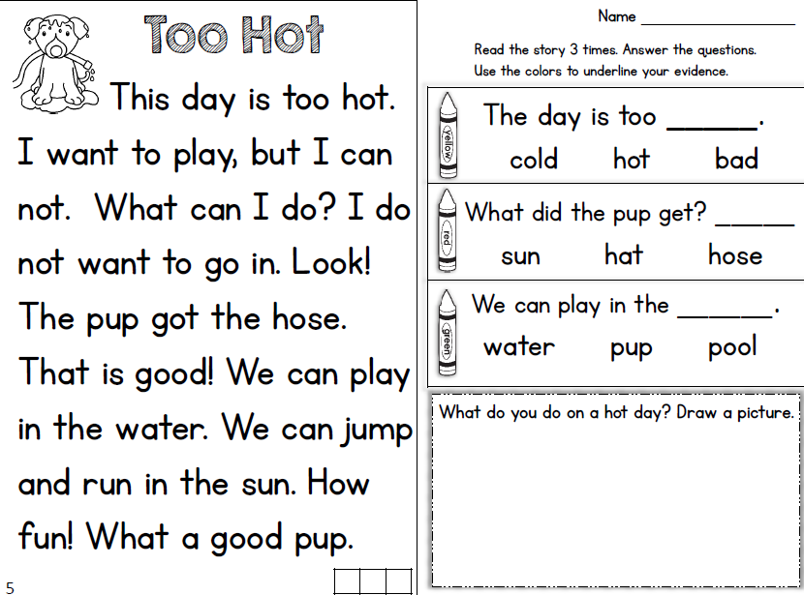
Tuesday- Reading

Tuesday- Reading
Read a book and complete this story map
Tuesday- Reading

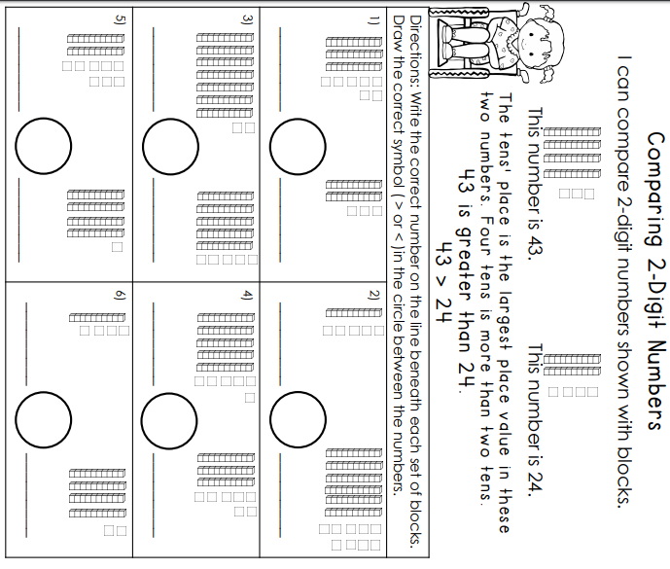
Tuesday- Math
Tuesday- Skills
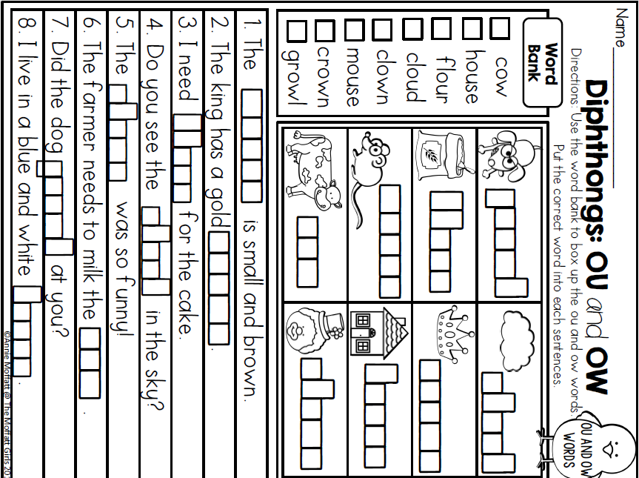
Wednesday Activity Schedule
- Check It Off When Completed | Activity
 | Morning Work
 | Writing a story
 | Independent Reading 20 minutes
 | Reading Comprehension Worksheet
 | 40 minutes of Lexia or RazKids
 | Math Worksheet
 | 40 minutes of SplashMath or Zearn
 | Skills Worksheet
 | *Choice activity time: pick an activity from the ClassDojo class story (watch a read aloud, try a learning website, or reading journal entry) or independent read for 20 minutes
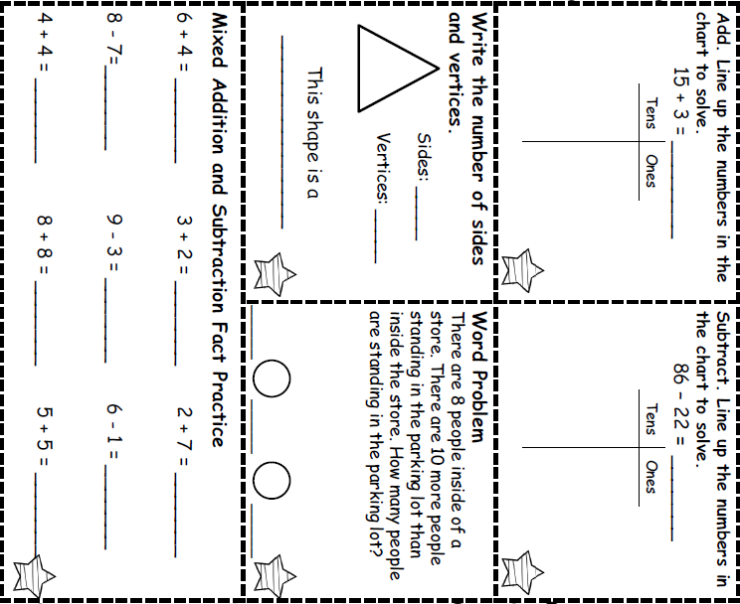
(Corners)
Corners)
Morning Work- Wednesday
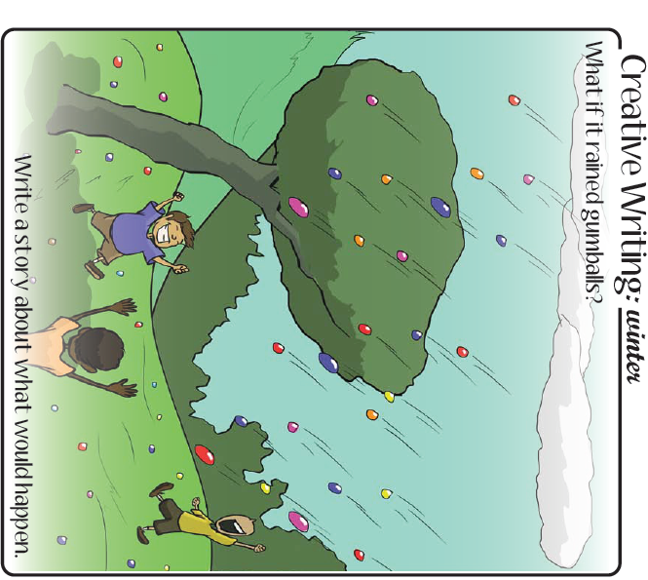

___________________________________________________________________________________________________________________________________________________________________________________________________________________________________________________________________________________________________________________________________________________________________________________________________________________________________________________________________________________________
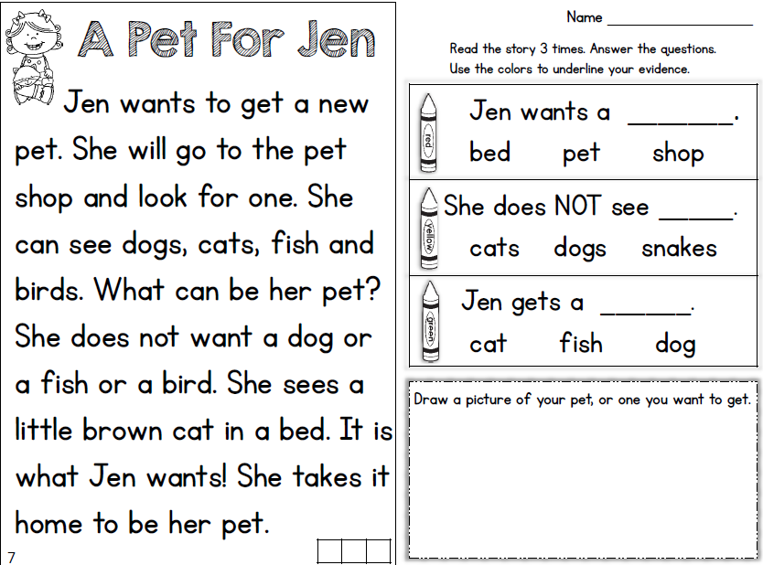
Wednesday - Reading

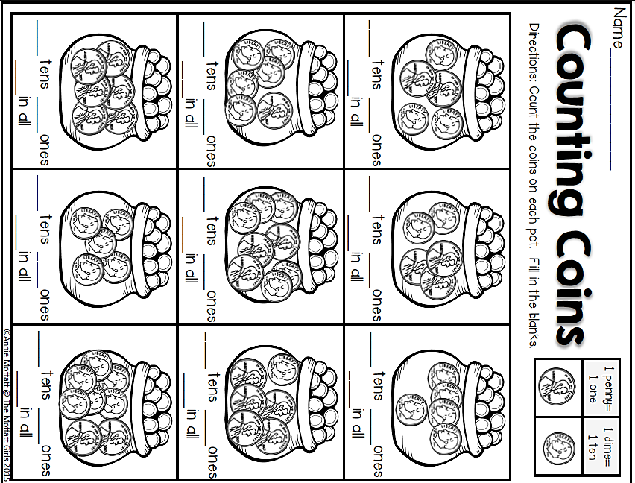
Wednesday- Math

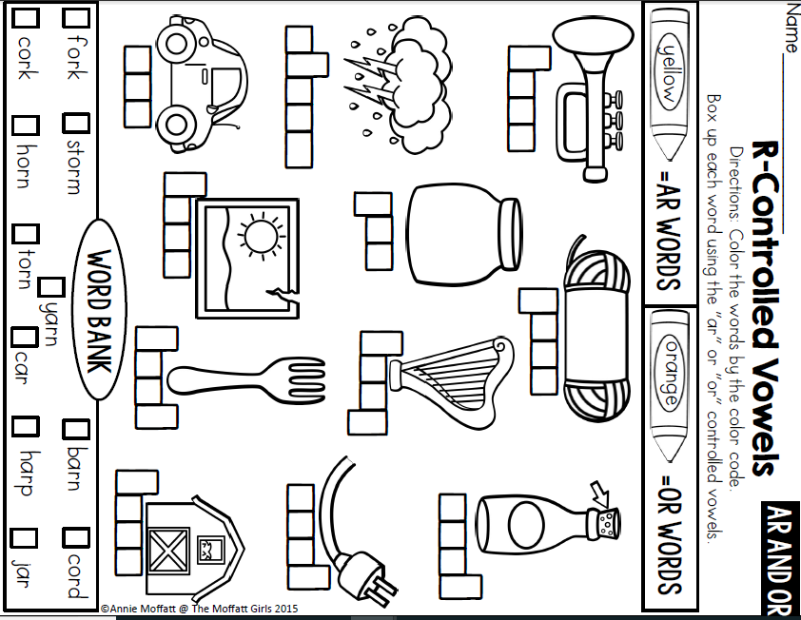
Wednesday- Skills

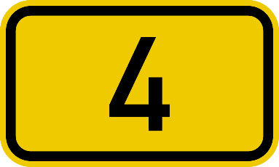

Thursday Activity Schedule
- Check It Off When Completed | Activity
 | Morning Work
 | Writing a story
 | Reading Comprehension Worksheet
 | Independent Reading 20 Minutes
 | Book story map
 | 30 minutes of Lexia or RazKids
 | Math Worksheet
 | 30 minutes of SplashMath or Zearn
 | Skills Worksheet
 | *Choice activity time: pick an activity from the ClassDojo class story (watch a read aloud, try a learning website, or reading journal entry) or independent read for 20 minutes

Morning Work- Thursday
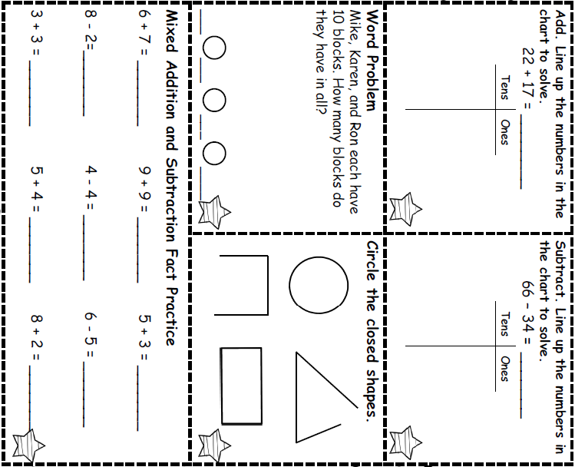


Words to use:
- squirrel
- sneaky
- peanut butter cup
- hungry

_______________________________________________________________________________________________________________________________________________________________________________________________________________________________________________________________________________________________________________________________________________________________________________________________________________________________________________________________________________________________________________________________________________________________________________
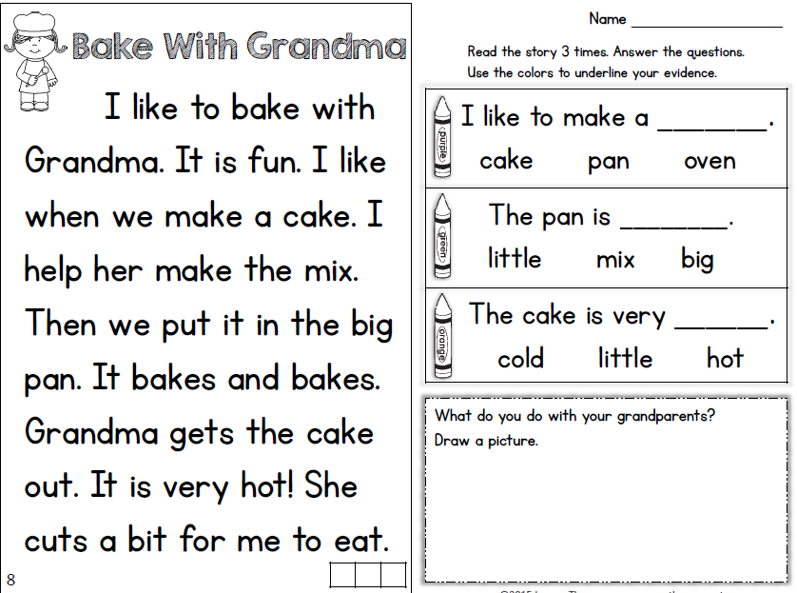
Thursday- Reading

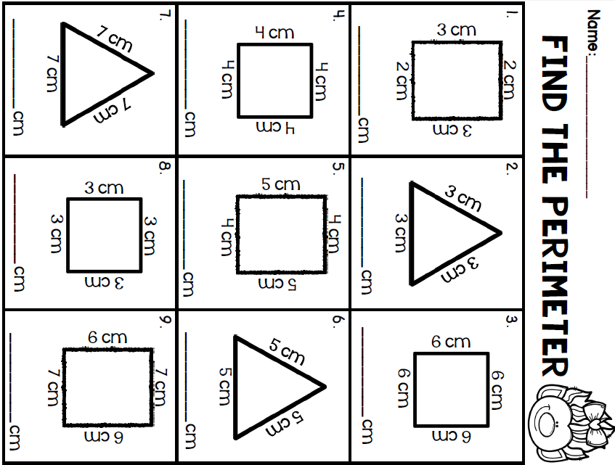
Add all sides together!
Thursday- Math

Thursday Skills
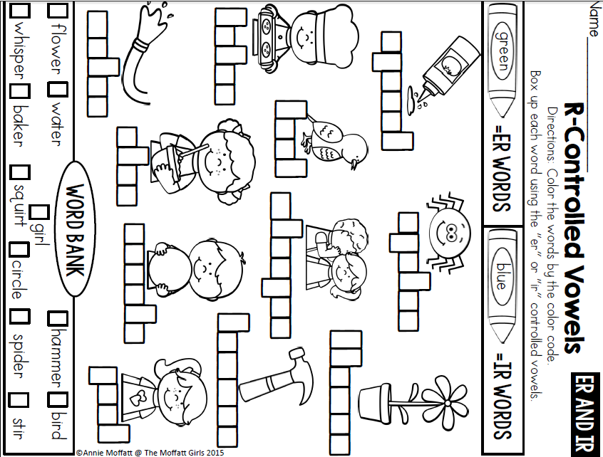

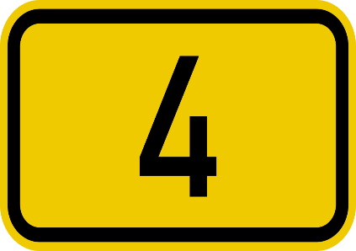

Friday Activity Schedule
- Check It Off When Completed | Activity
 | Morning Work
 | Writing a story
 | Independent reading 20 minutes
 | Reading Comprehension page
 | 40 minutes of Lexia or RazKids
 | Math Worksheet
 | 40 minutes of SplashMath or Zearn
 | Skills Worksheet
 | *Choice activity time: pick an activity from the ClassDojo class story (watch a read aloud, try a learning website, or reading journal entry) or independent read for 20 minutes

Morning Work- Friday
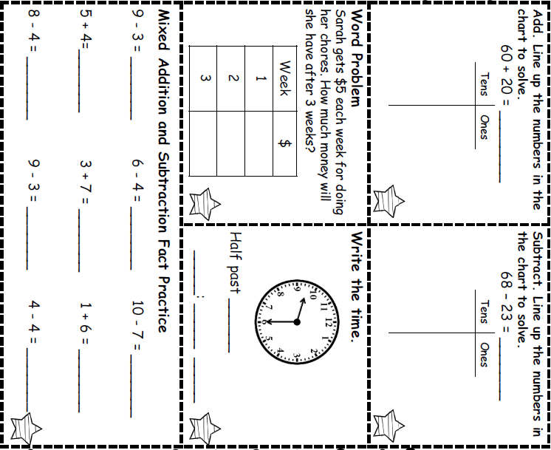


Words to use:
- giraffe
- tree
- climb
- scared

_______________________________________________________________________________________________________________________________________________________________________________________________________________________________________________________________________________________________________________________________________________________________________________________________________________________________________________________________________________________________________________________________________________________________________________
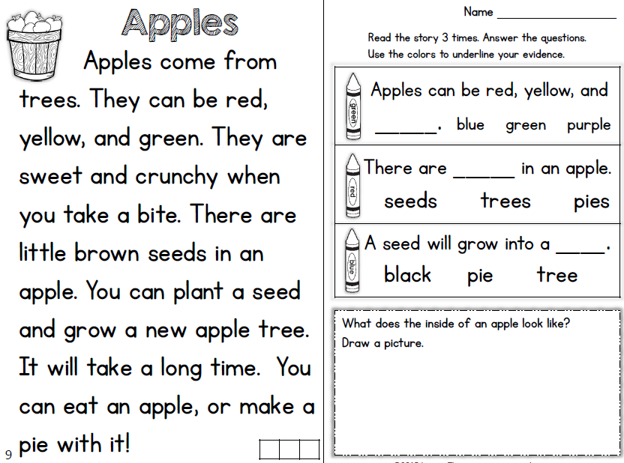
Friday Reading

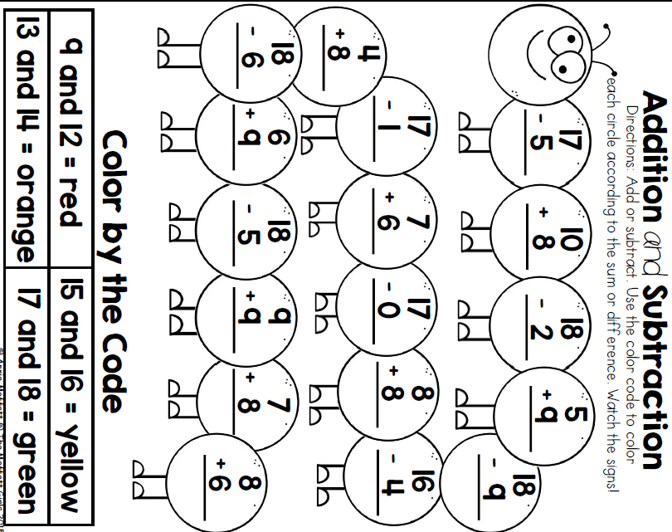
Friday Math

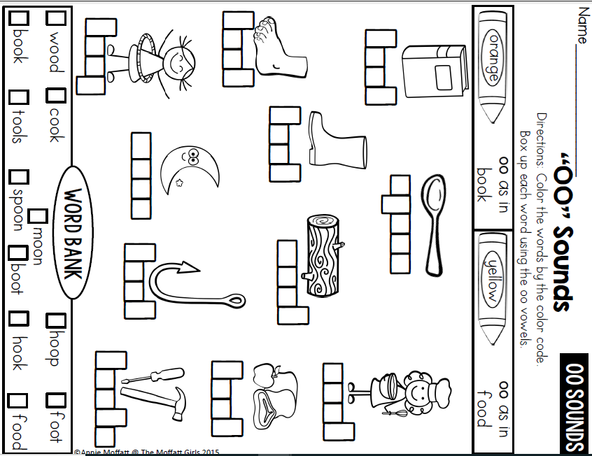
Friday Skills

Monday Activity Schedule
- Check It Off When Completed | Activity
 | Morning Work
 | Reading Comprehension Worksheet
 | Independent reading 20 minutes
 | Book Story Map
 | 25 minutes of Lexia or RazKids
 | Math Worksheet
 | 30 minutes of SplashMath or Zearn
 | Skills Worksheet
 | *Choice activity time: pick an activity from the ClassDojo class story (watch a read aloud, try a learning website, or reading journal entry) or independent read for 20 minutes
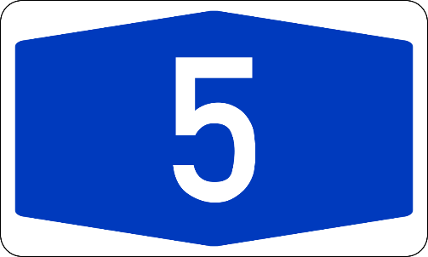
Morning Work- Monday
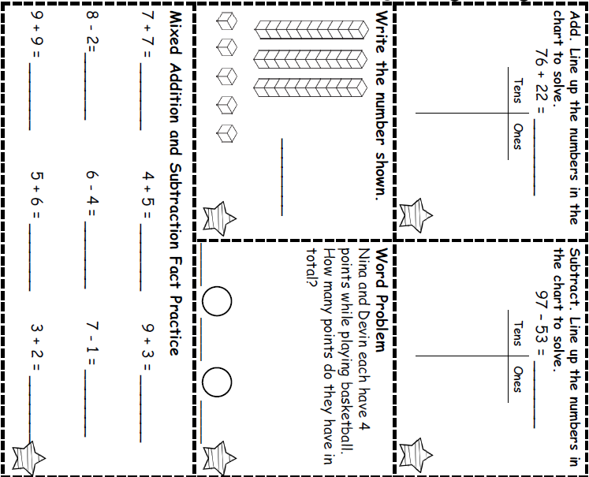

Monday- Reading
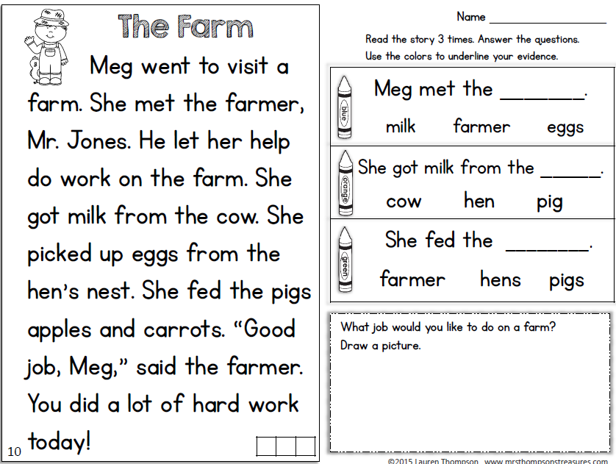

* Read a book and complete this story map.****
Monday- Reading
Monday- Math
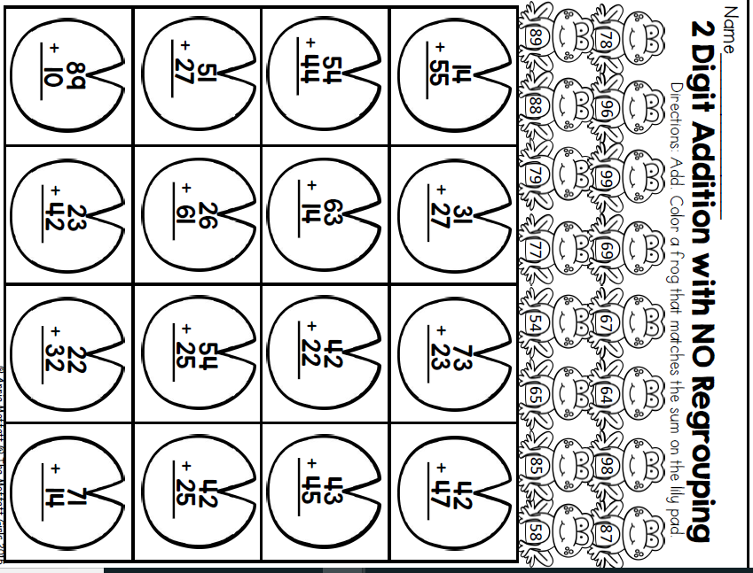
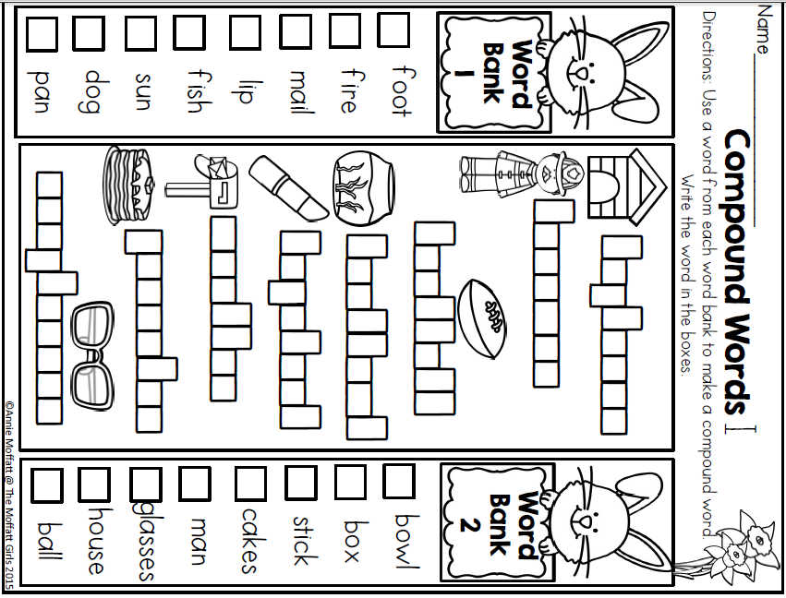
Monday- Skills
Tuesday Activity Schedule
- Check It Off When Completed | Activity
 | Morning Work
 | Writing a story Worksheet
 | Reading Comprehension
 | Independent reading 20 minutes & Book Story Map
 | 25 minutes of Lexia or RazKids
 | Math Worksheet
 | 30 minutes of SplashMath or Zearn
 | Skills Worksheet
 | *Choice activity time: pick an activity from the ClassDojo class story (watch a read aloud, try a learning website, or reading journal entry) or independent read for 20 minutes
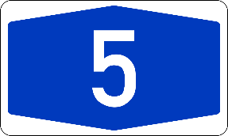
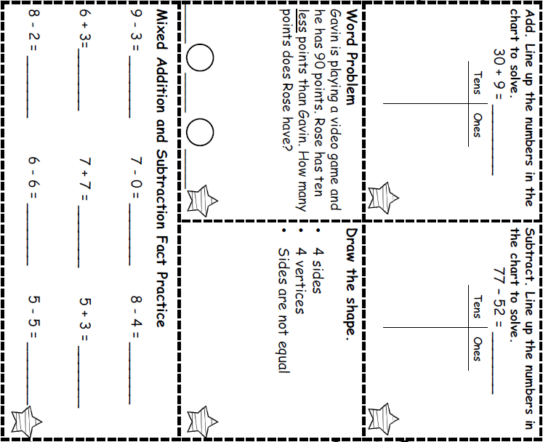
Morning Work- Tuesday

(Corners)

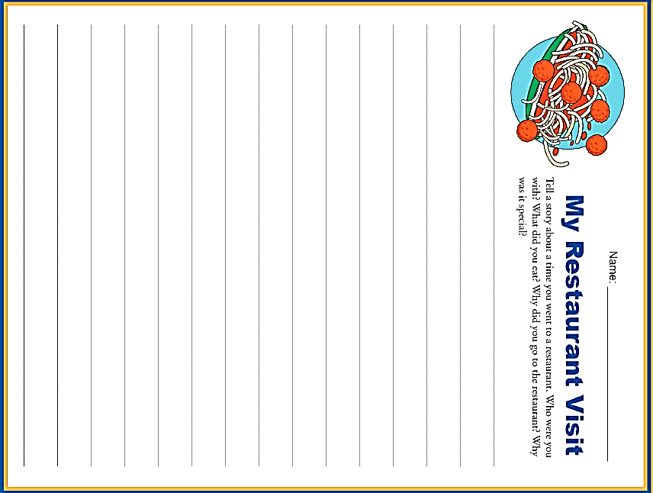

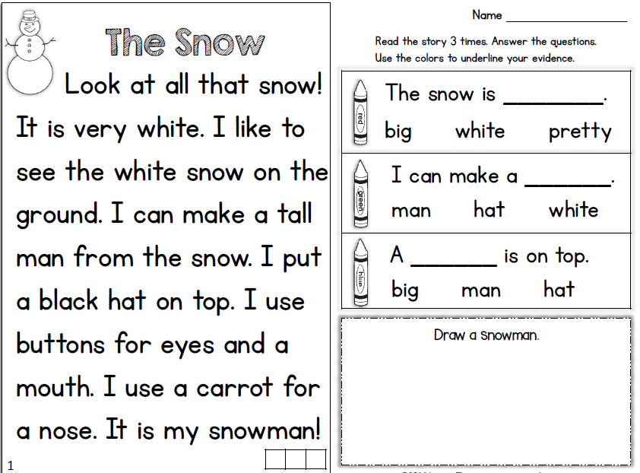
Tuesday- Reading

Read a book and complete this story map
Tuesday- Reading

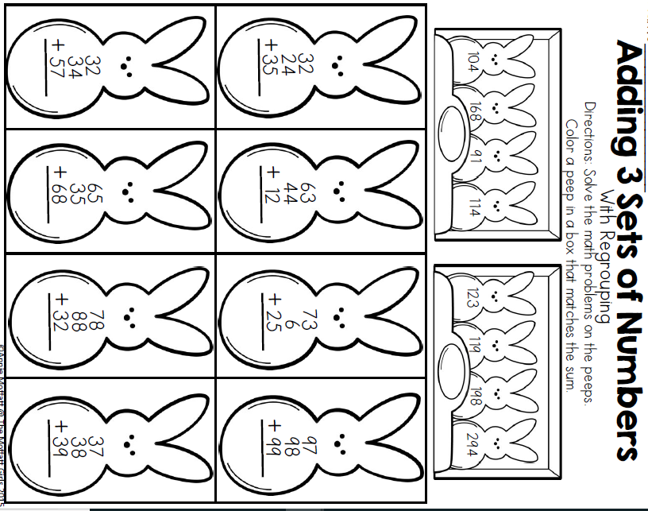
Tuesday- Math
Tuesday- Skills
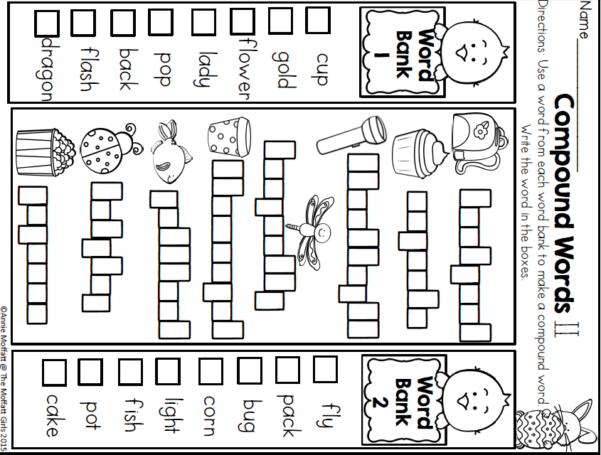
Wednesday Activity Schedule
- Check It Off When Completed | Activity
 | Morning Work
 | Writing a story
 | Independent Reading 20 minutes
 | Reading Comprehension Worksheet
 | 40 minutes of Lexia or RazKids
 | Math Worksheet
 | 40 minutes of SplashMath or Zearn
 | Skills Worksheet
 | *Choice activity time: pick an activity from the ClassDojo class story (watch a read aloud, try a learning website, or reading journal entry) or independent read for 20 minutes
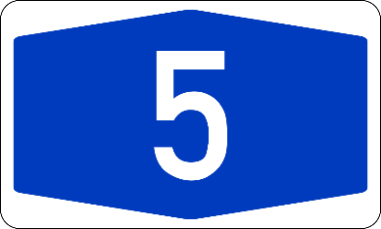
Morning Work- Wednesday
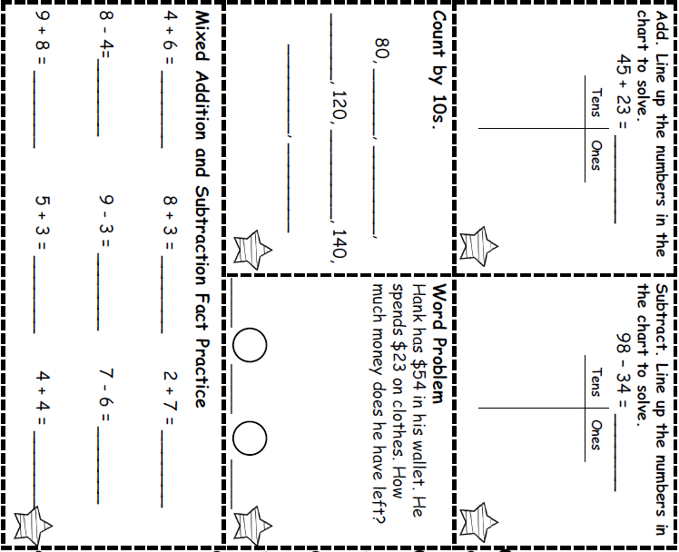

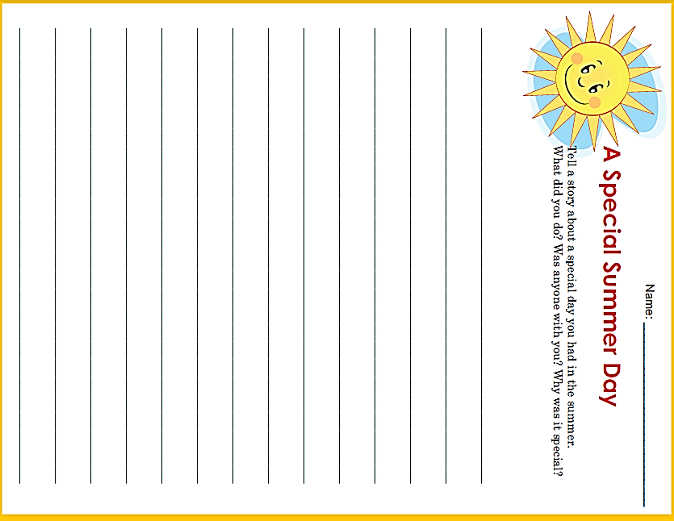

Wednesday - Reading
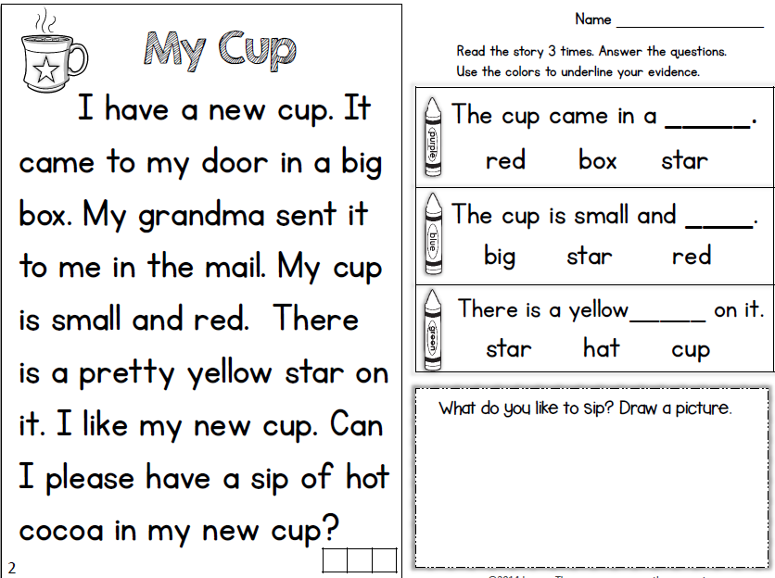
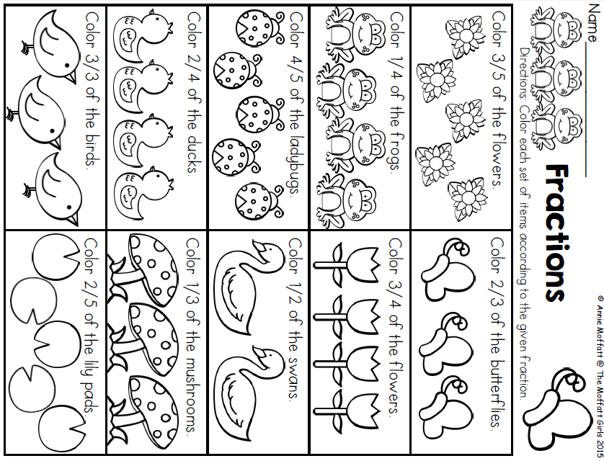
Wednesday- Math

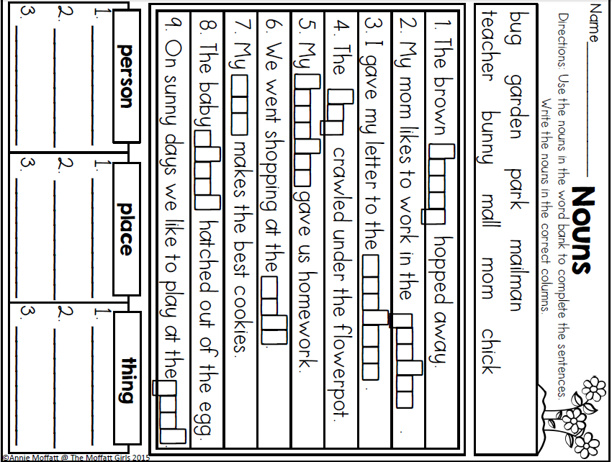
Wednesday- Skills

Thursday Activity Schedule
- Check It Off When Completed | Activity
 | Morning Work
 | Reading Comprehension Worksheet
 | Independent Reading 20 Minutes
 | Book story map
 | 30 minutes of Lexia or RazKids
 | Math Worksheet
 | 30 minutes of SplashMath or Zearn
 | Skills Worksheet
 | *Choice activity time: pick an activity from the ClassDojo class story (watch a read aloud, try a learning website, or reading journal entry) or independent read for 20 minutes

Morning Work- Thursday

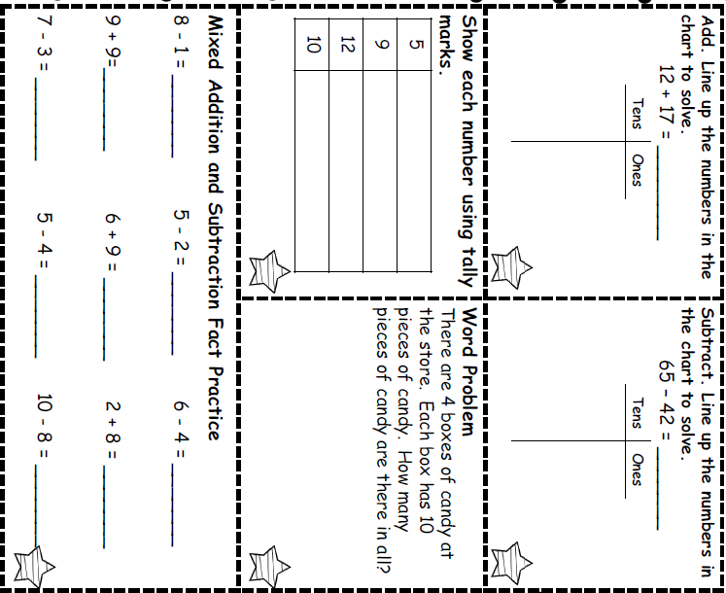

Thursday- Reading
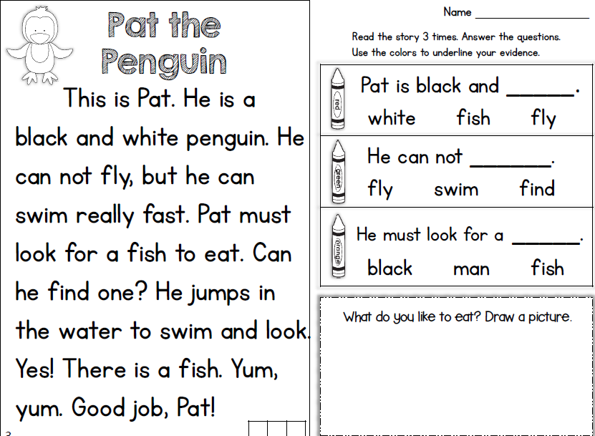

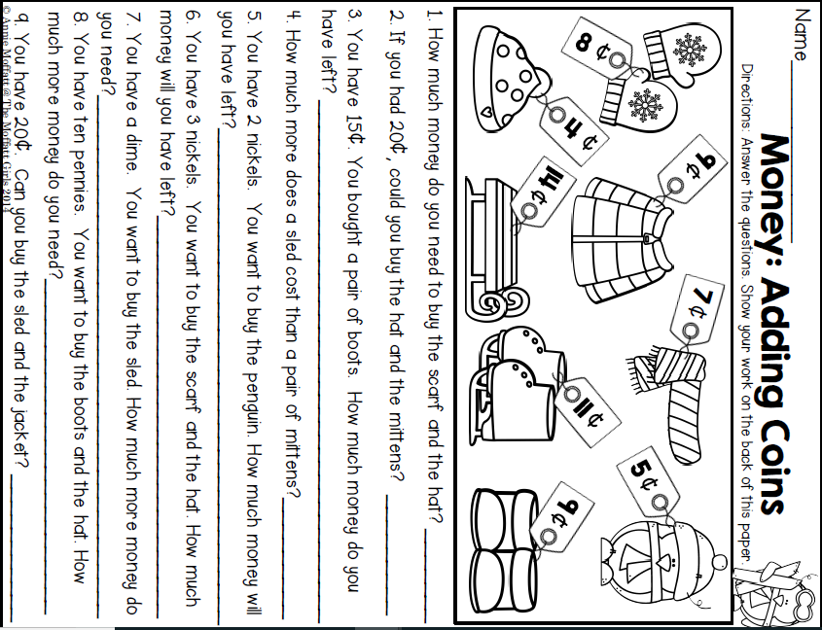
Thursday- Math

Thursday Skills
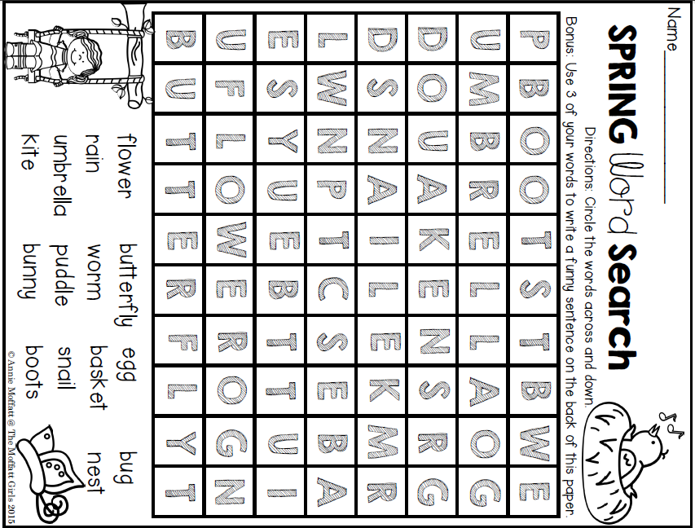

Friday Activity Schedule
- Check It Off When Completed | Activity
 | Morning Work
 | Writing a story
 | Independent reading 20 minutes
 | Reading Comprehension page
 | 40 minutes of Lexia or RazKids
 | Math Worksheet
 | 40 minutes of SplashMath or Zearn
 | Skills Worksheet
 | *Choice activity time: pick an activity from the ClassDojo class story (watch a read aloud, try a learning website, or reading journal entry) or independent read for 20 minutes

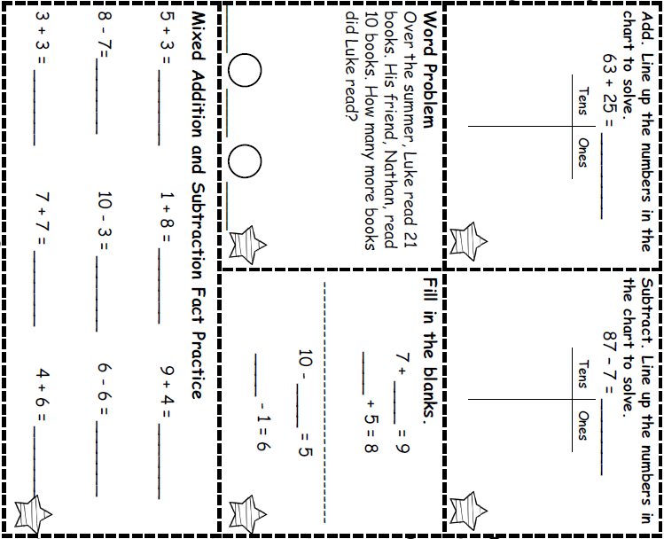
Morning Work- Friday
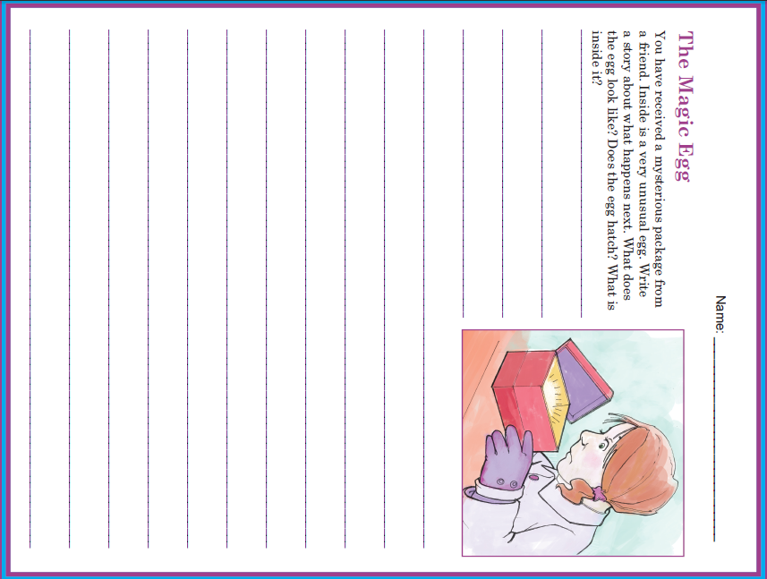

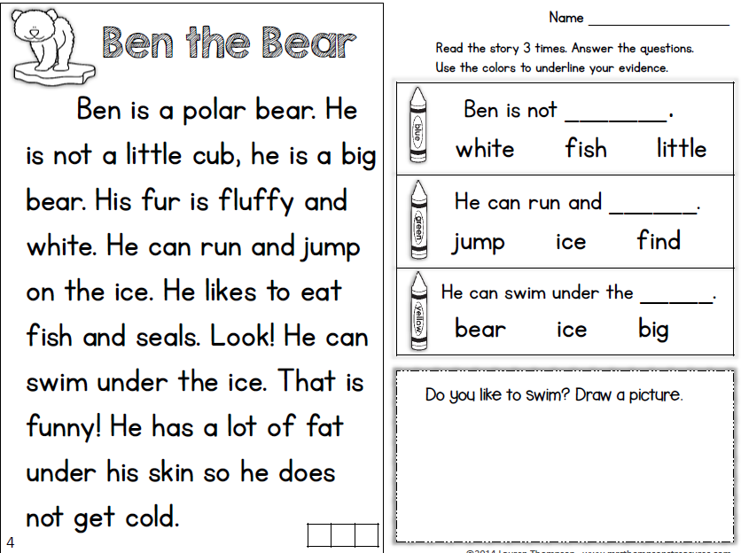
Friday Reading

Friday Math

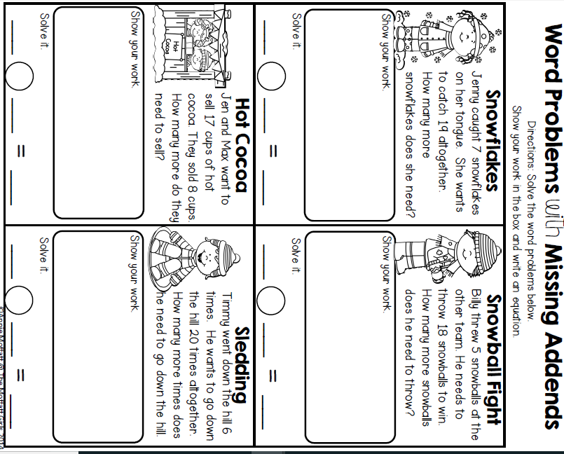

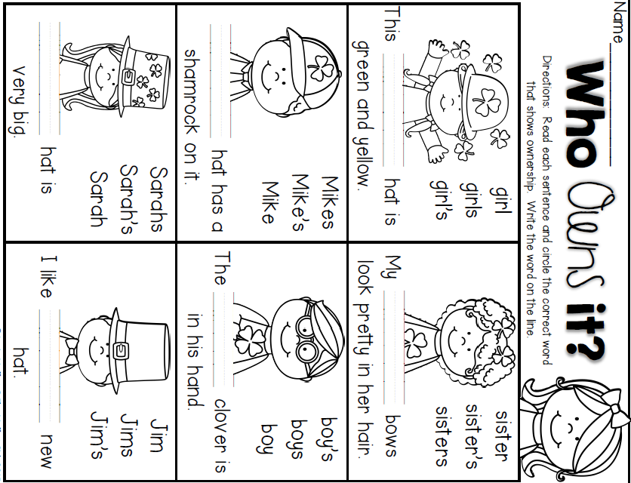
Friday Skills

